
HOUSING AUTHORITY
of the County of Riverside

Riverside Main Office
5555 Arlington Ave
Riverside, CA 92504
(951) 351-0700

Website:harivco.org
rbeltran@rivco.org

ADDENDUM #1
Date: September 8, 2026

From: Tamico Thomas, Supervising Development Specialist

Project: IFB No. 2025-009 HACR Administrative Parking Lot Recoating and Expansion Project – Revision 2

Location: 5555 Arlington Ave., Riverside, CA 91504

Bid Due Date: Tuesday, September 15, 2026, at 2:00 PM PST
The bid due date remains unchanged.

NOTICE TO BIDDERS
This Addendum provides written responses and clarifications arising from the pre-bid meeting/job walk for the above-referenced solicitation. The information contained in this Addendum is incorporated into the solicitation documents and shall be considered by bidders in preparing their bids. Except as expressly modified or clarified herein, all other terms, conditions, specifications, and requirements of IFB No. 2025-009, Revision 2 remain unchanged.
Bidders are responsible for acknowledging this Addendum in accordance with the solicitation requirements. Questions and requests for information remain subject to the published September 2, 2026, at 2:00 PM deadline.

Pre-Bid Questions and Responses
1. Question: Will the employee vehicles be moved that day?
Response: Yes. Preferably, if the new parking lot is completed first, employee vehicles may be relocated to the new parking area so that work can proceed in the existing parking lot.
2. Question: Will employee parking have any parking stops?
Response: Yes. Parking stops will be installed only along the side adjacent to the brick wall.
3. Question: Are you replacing everything that currently exists, including the yellow paint around the drains?
Response: Yes. Existing striping and painted markings shall remain generally consistent with the existing layout. No designated or special parking areas will be provided, except for one additional ADA parking stall. Yellow paint shall remain around all existing drainage points.
4. Question: Will there be reserved parking, or will all parking spaces be plain?
Response: No reserved parking will be provided. Parking spaces will remain standard/plain spaces without reserved designations, except where required for ADA compliance.
5. Question: Asphalt patching – What are the approximate quantities, and how wide should the patches be?
Response: For bidding purposes, use approximately 5% of the 52,839 SF parking lot area, or approximately 2,642 SF, as the asphalt repair quantity. Repairs are intended for areas exhibiting water damage, pavement deterioration, potholes, and other failed conditions. The Contractor shall properly remove and repair damaged areas prior to application of the slurry seal coat.
Recommended bidding quantities/allowances:
Slurry Seal: 52,839 SF
Asphalt Repairs: 2,642 SF (approximately 5%)
Crack Sealing: 4,500 LF allowance
ADA Stall: 1 EA
Tree Stump Removal: 1 EA
Tree Removal: 1 EA

Patch dimensions shall be based on the limits of actual failed pavement encountered and shall be sufficient to remove and replace the deteriorated material.
6. Question: Will chips in the curb need to be repaired?
Response: Yes. Curb damage or chips larger than approximately 1 inch shall be properly patched and repaired.
7. Question: Will an ADA parking stall be installed near the tree? Does the area need to be flattened?
Response: No ADA parking stall will be installed in the new parking lot. One additional ADA parking stall will be added to the existing parking lot.
8. Question: Will the tree stump need to be removed for the one-way path?
Response: Yes. The existing tree stump shall be completely removed to accommodate the one-way path.
9. Question: Will the existing trees remain?
Response: Yes. All existing trees will remain except for the last tree located adjacent to the wall, looking toward the apartments where the one-way traffic lane will exit. That tree shall be removed.
10. Question: Will the paving extend all the way to the wall?
Response: Yes. The paving shall extend all the way to the wall.
11. Question: Is there an engineer's estimate available for bonding purposes?
Response: No. An engineer's estimate is not currently available.
12. Question: Does the driveway ramp to the field remain?
Response: No. The driveway shall be modified so that it is level/even at both ends.
13. Question: Will this be a Design-Build project?
Response: Yes. The project will be completed as a Design-Build project.
14. Question: Multiple questions were asked regarding City vs. County jurisdiction.
Response: It is anticipated that permitting and inspections will be handled through Riverside County rather than the City of Riverside. However, the Contractor is responsible for verifying the applicable jurisdiction, permit requirements, fees, approvals, and inspections with the appropriate governmental authority before proceeding. Bidders should not rely solely on this anticipated jurisdictional determination.
15. Question: Will the LED lights be installed on the existing poles?
Response: Yes. Existing light poles will be utilized for installation of LED lighting, where applicable.
16. Question: Will everyone receive an emailed list of attendees?
Response: Yes. The pre-bid attendee/sign-in list will be distributed by email.
17. Question: Is there a sign-in sheet from the site walk held on 8/26 available?
Response: Yes. The sign-in sheet from the mandatory job walk held on August 26, 2026, is available. It will be distributed separately by email to the attendees who participated in the mandatory job walk and will also be included as Attachment A to the posted Q&A/Addendum.
18. Question: Is there an estimated cost or budget for this project?
Response: No. HACR is not providing an estimated project cost or budget for this solicitation. Bidders should submit pricing based on the scope of work and requirements outlined in the IFB.
19. Question: Do you have an anticipated start date or completion date at this time?
Response: An anticipated start date has not been established at this time. The project completion timeframe is as stated in the IFB and is based on the issuance of the Notice to Proceed. The timing of the Notice to Proceed will depend on completion of the review, approval, and award process.
Attachment A - Mandatory Job Walk Attendance List
The public attendance list will identify the attendee and company represented. The original signed sign-in sheet will be retained in the procurement file.

Pre-Bid Sign-In Sheet
The pre-bid meeting/job walk attendee sign-in sheet is attached to or distributed with this Addendum and is provided for informational purposes.

Acknowledgment
Receipt of this Addendum shall be acknowledged as required by the solicitation. Failure to acknowledge an Addendum containing material changes may affect the responsiveness of a bid.
All other terms and conditions of IFB No. 2025-009 remain unchanged.
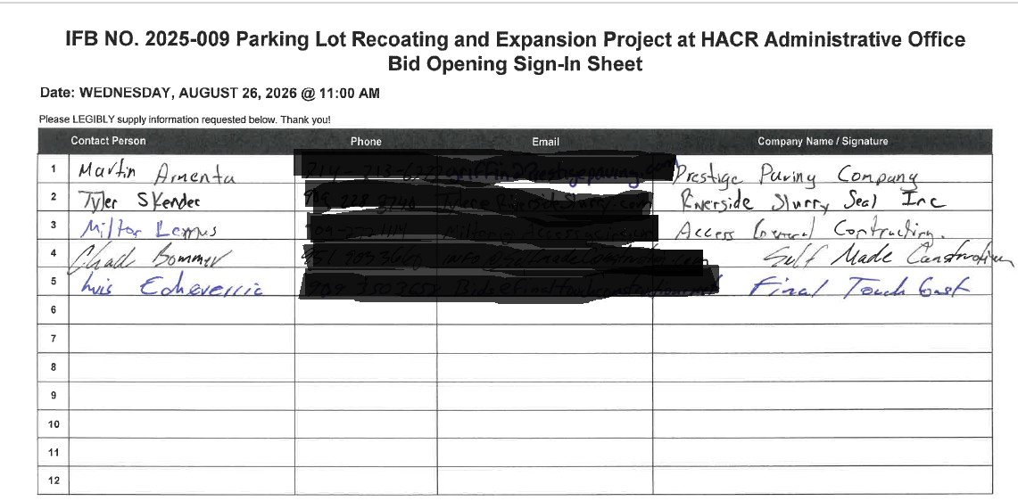
END OF ADDENDUM NO. 1

